**EEE LABS**

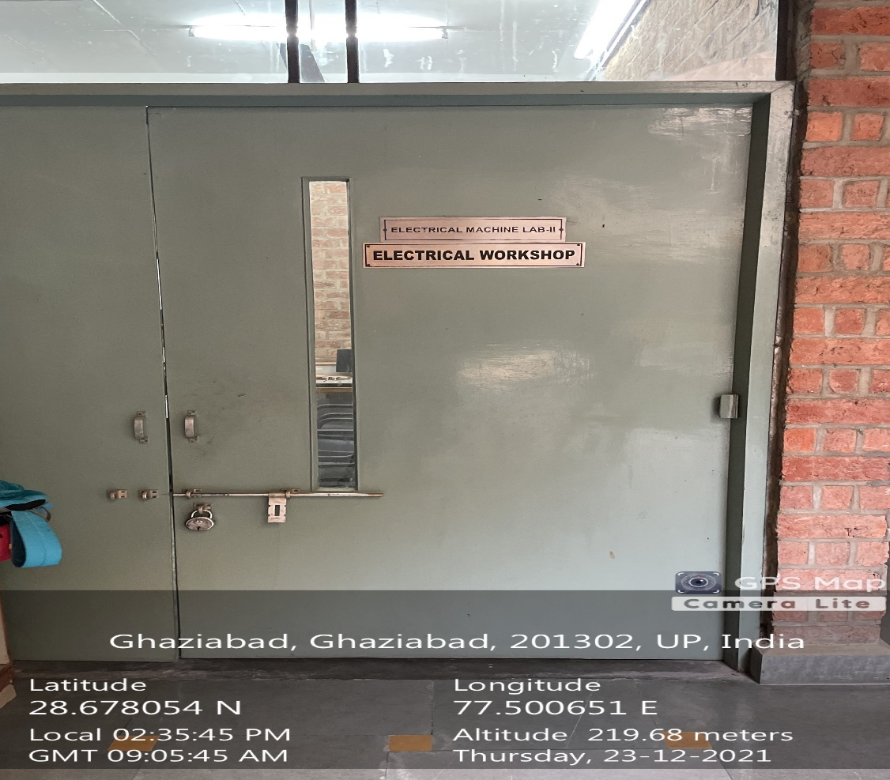

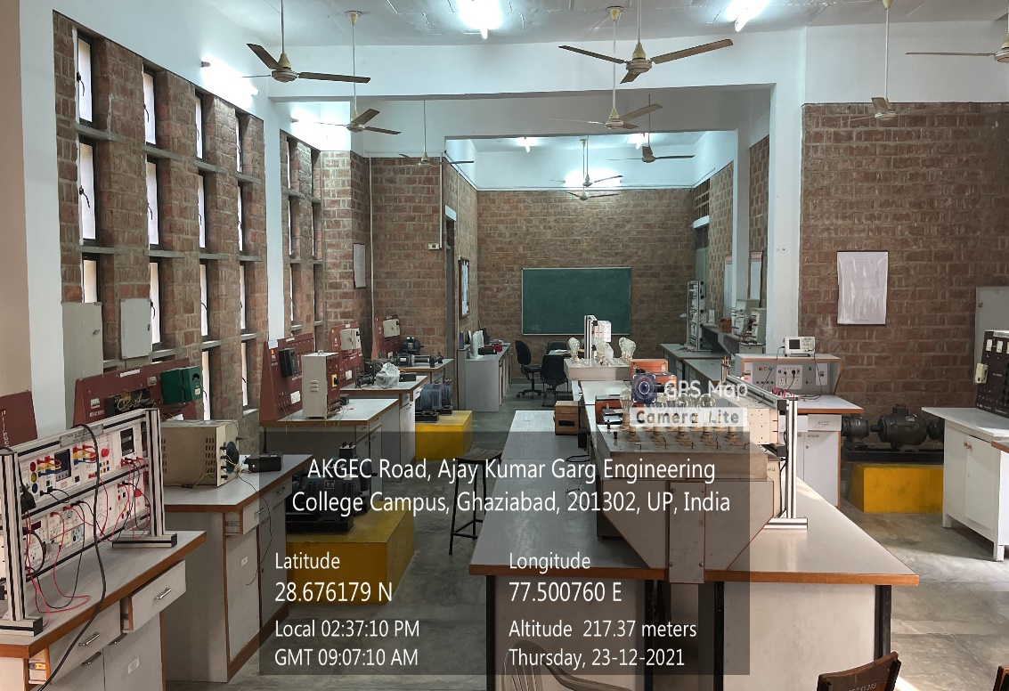

**BACK BLOCK GROUND FLOOR, ELECTRICAL MACHINE LAB**

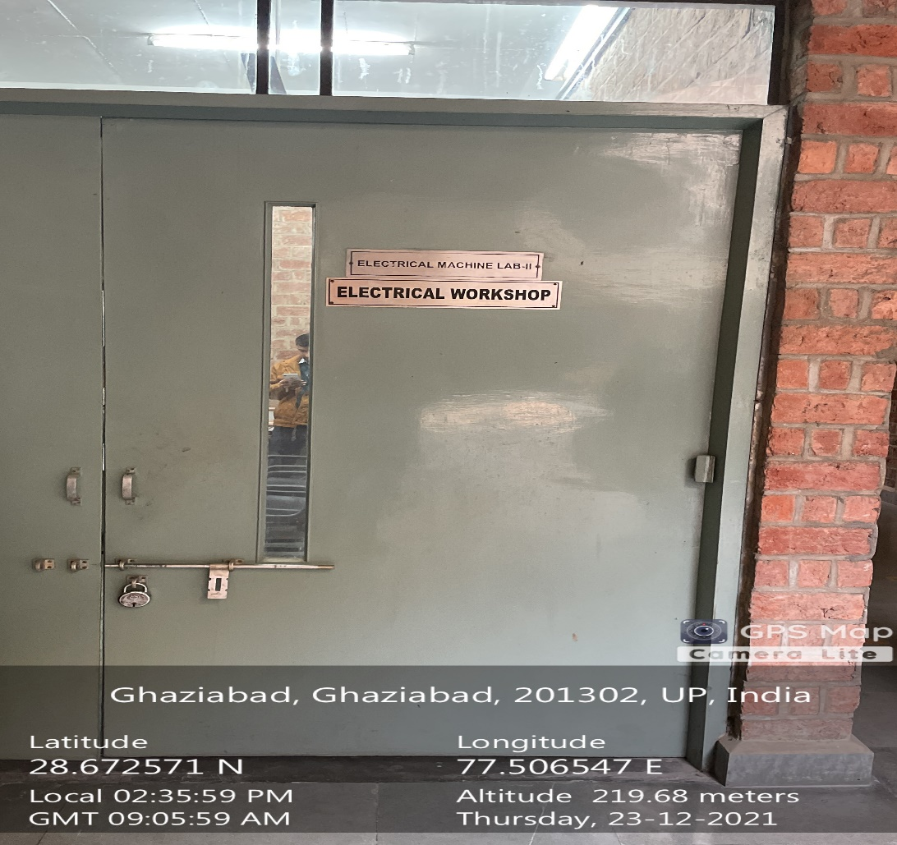

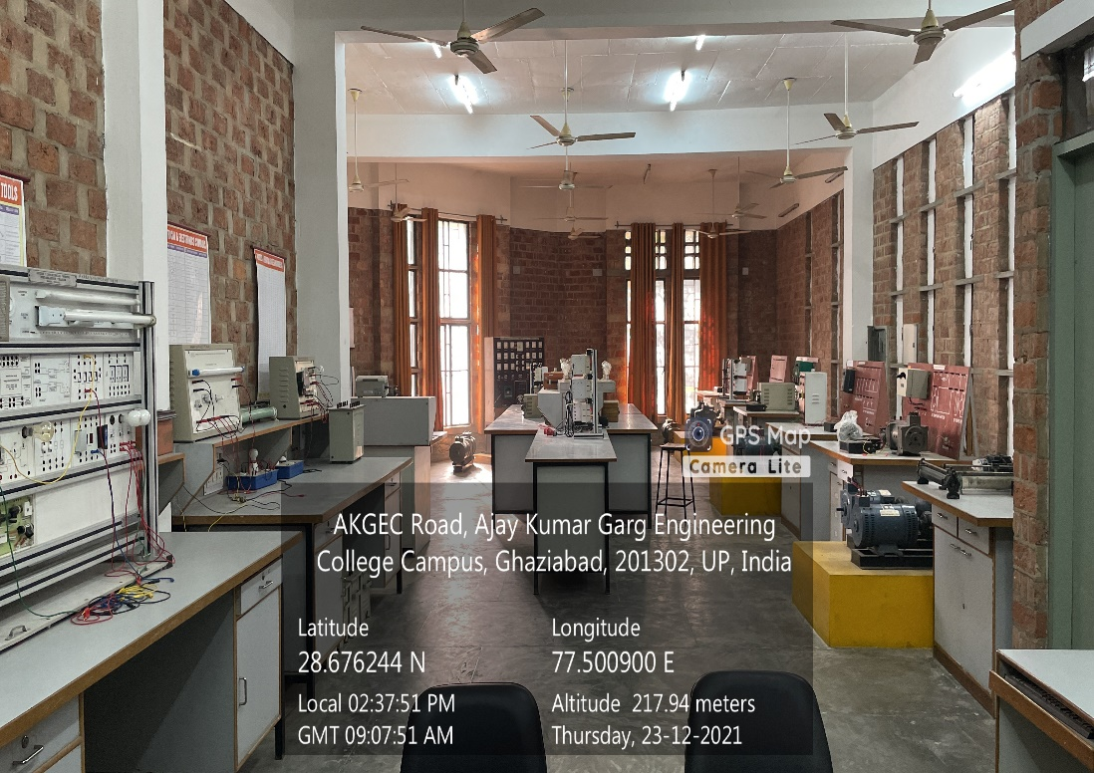

**BACK BLOCK GROUND FLOOR, ELECTRICAL WORKSHOP-2**

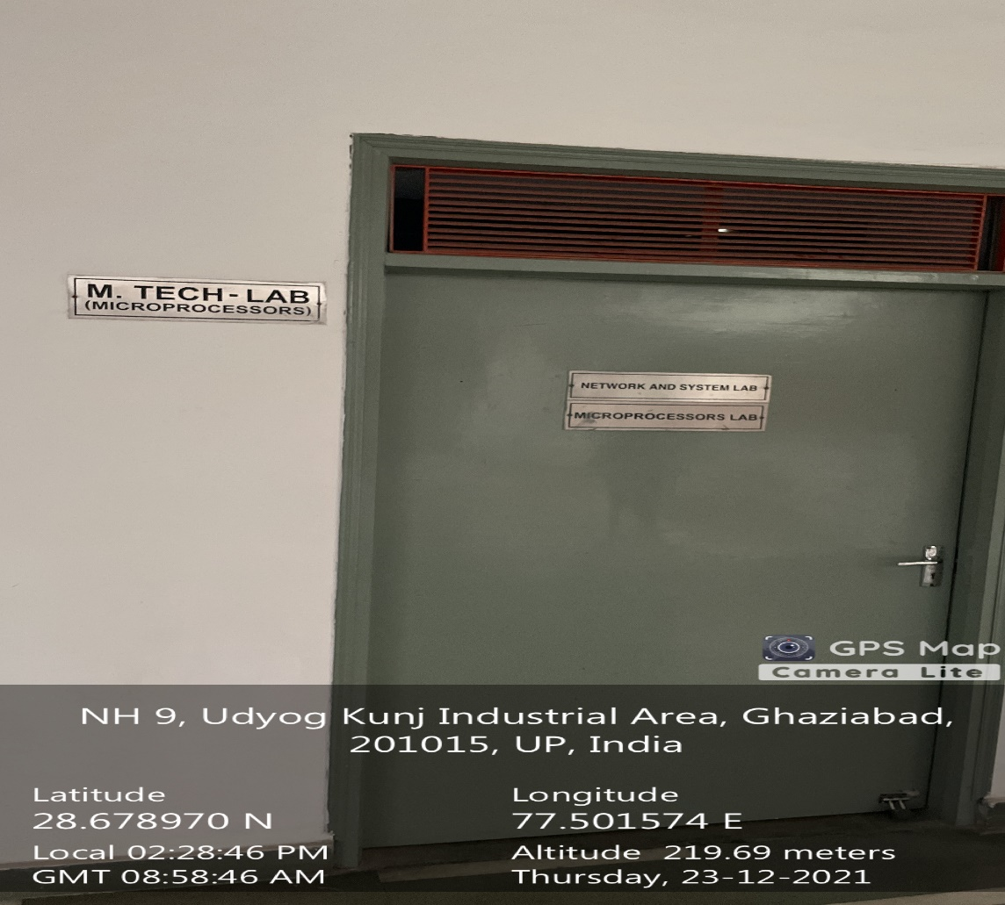

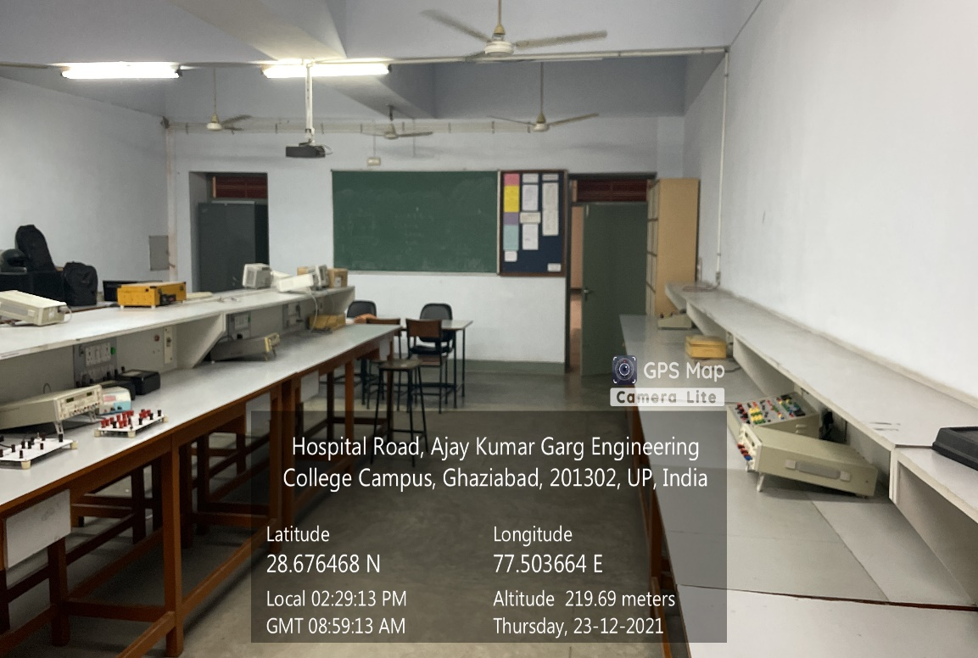

**Administrative Block Ground Floor, M.TECH MICROPROCESSOR LAB**

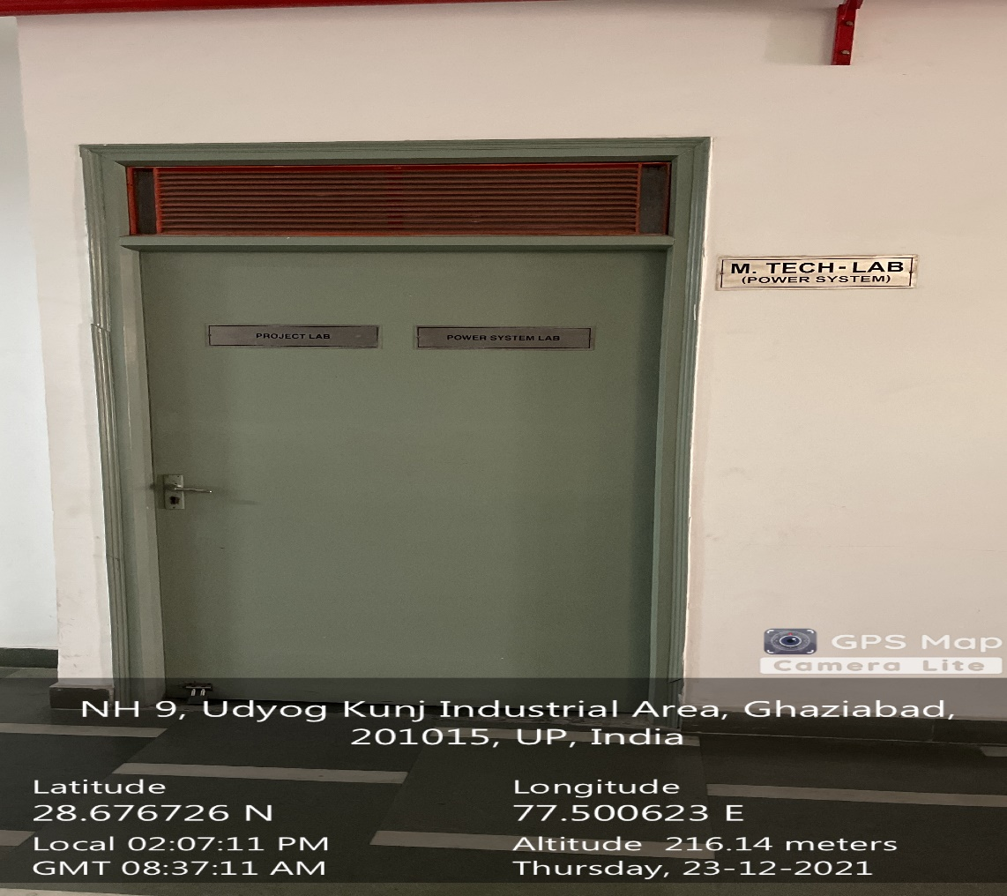

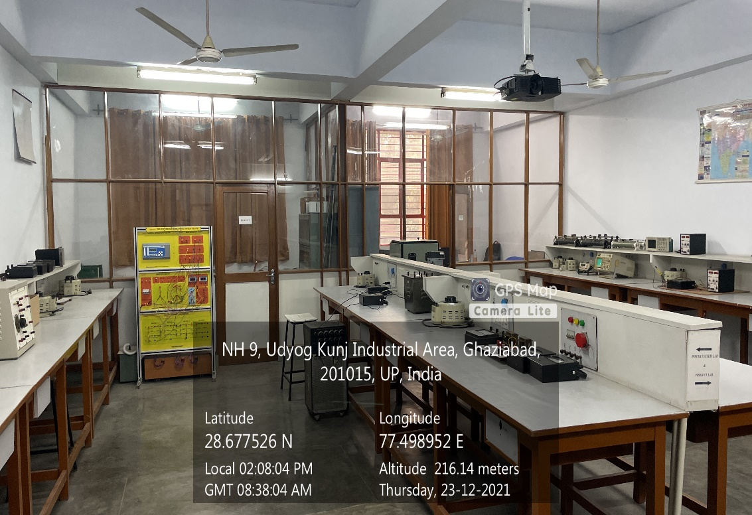

**ADMINISTRATIVE BLOCK GROUND FLOOR, POWER SYSTEM LAB**

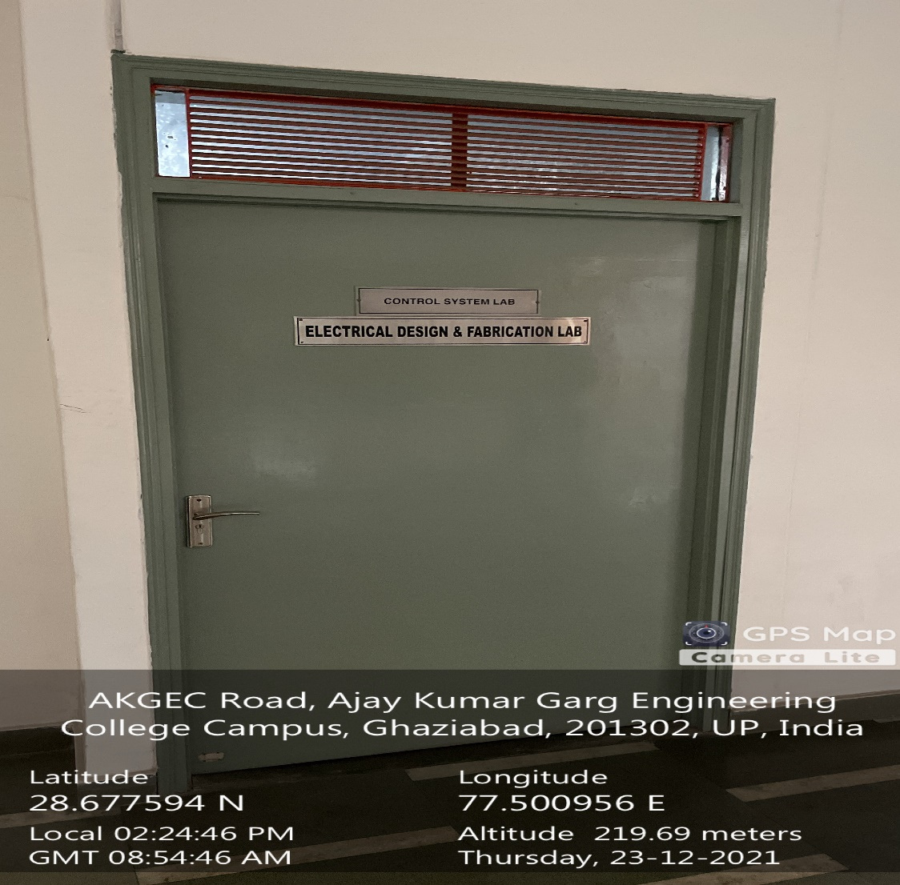

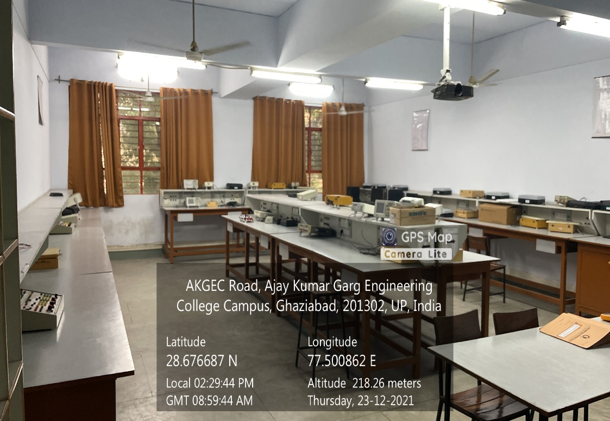

**ADMINISTRATIVE BLOCK GROUND FLOOR, CONTROL SYSTEM LAB**

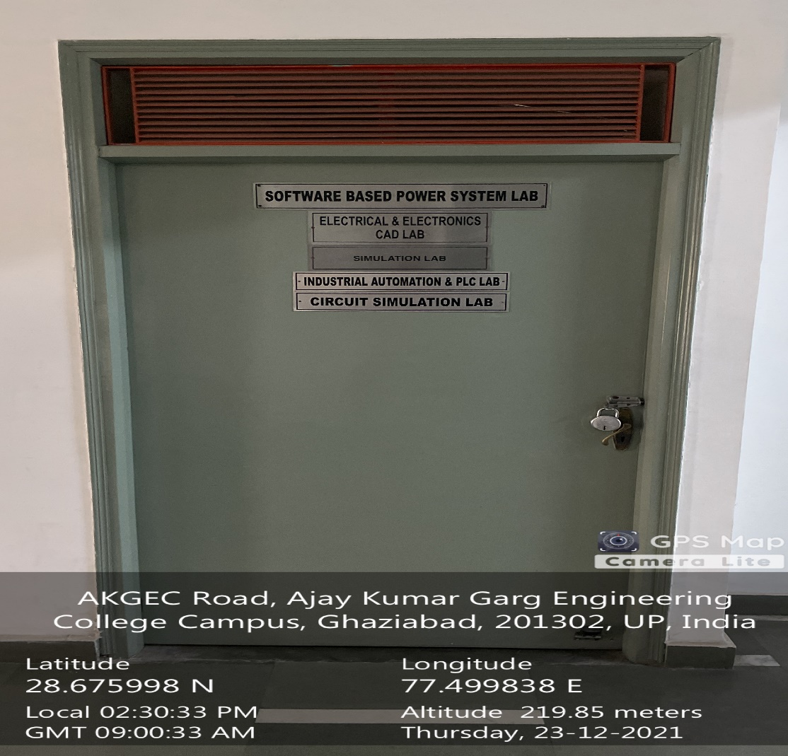

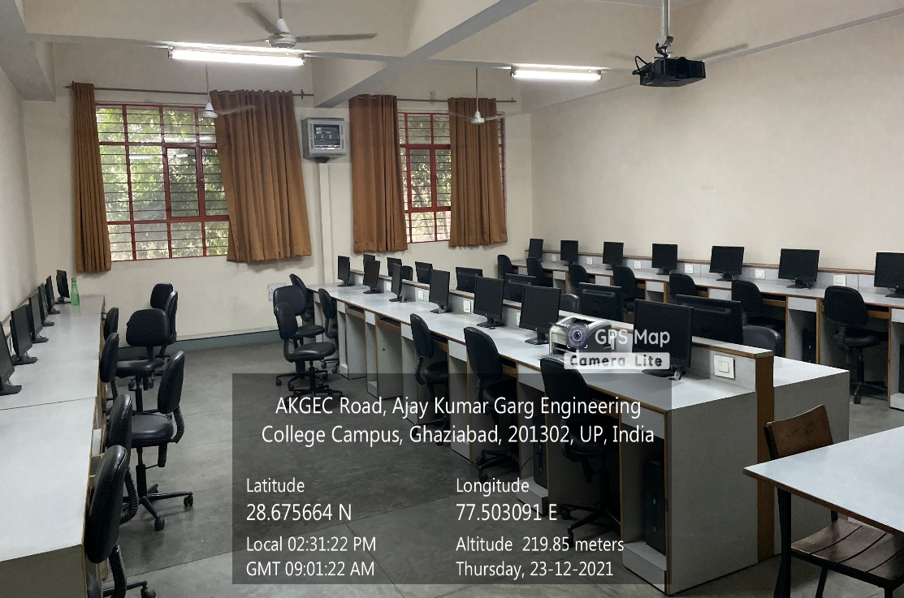

**ADMINISTRATIVE BLOCK GROUND FLOOR, ELECTRICAL & ELCTRONICS CAD LAB**

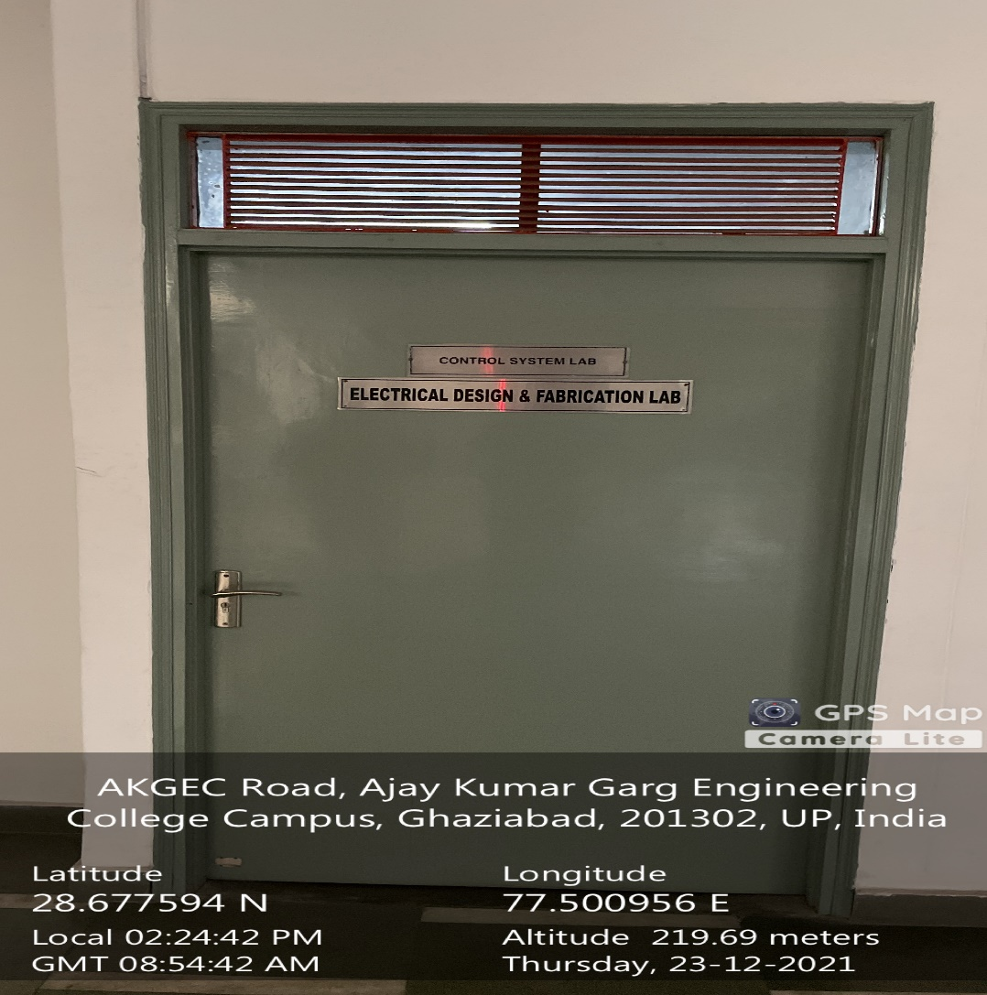

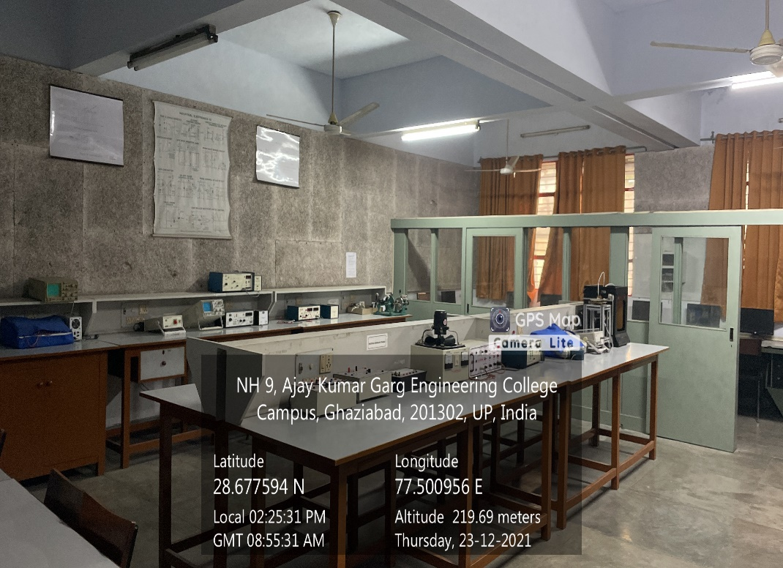

**ADMINISTRATIVE BLOCK GROUND FLOOR, ELECTRICAL DESIGN AND FABRICATION LAB**

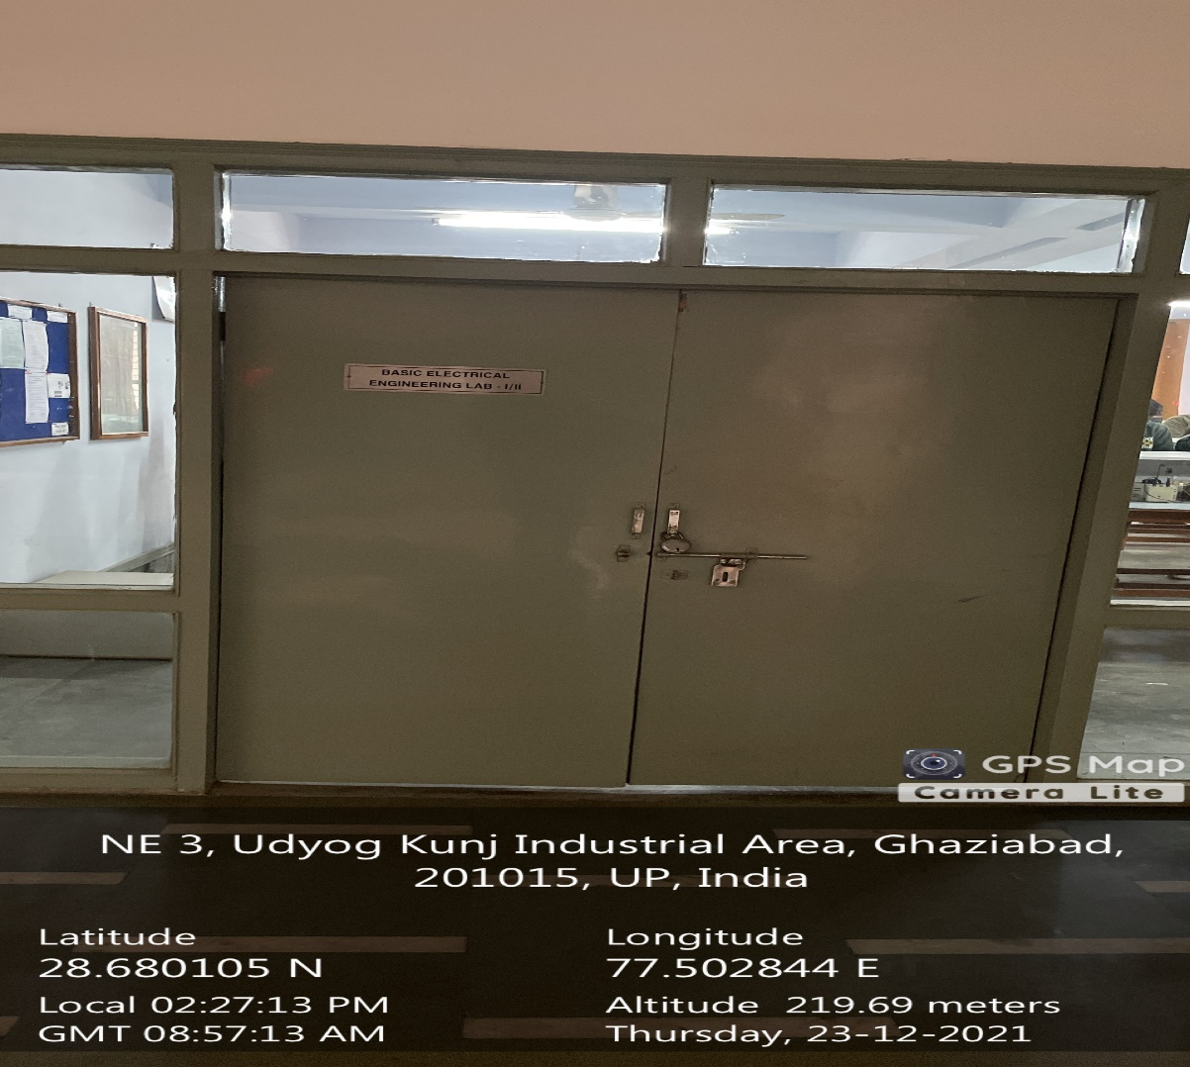

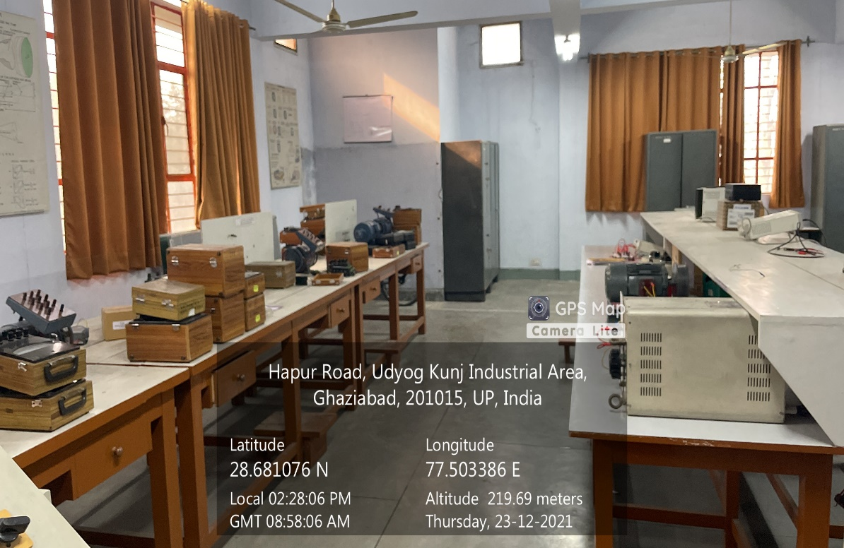

**ADMINISTRATIVE BLOCK GROUND FLOOR, ELECTRICAL ENGG. LAB**

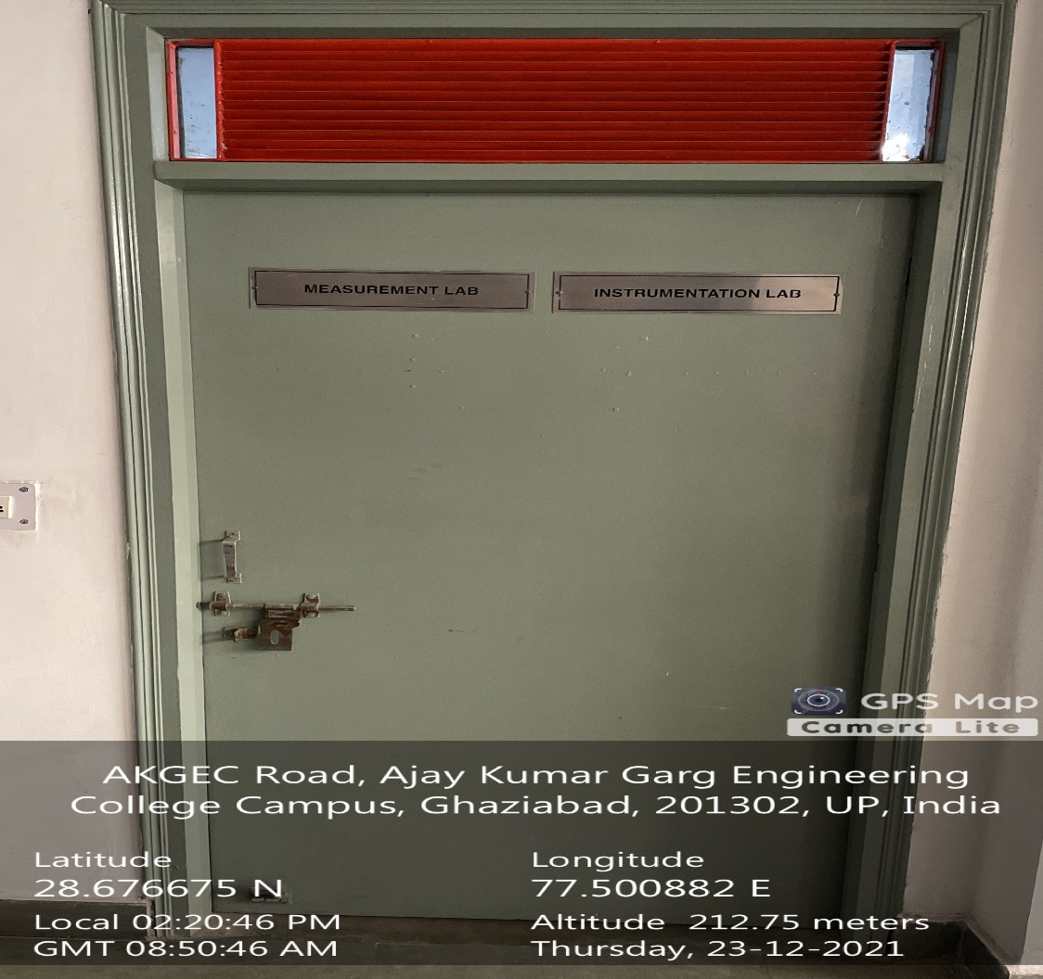

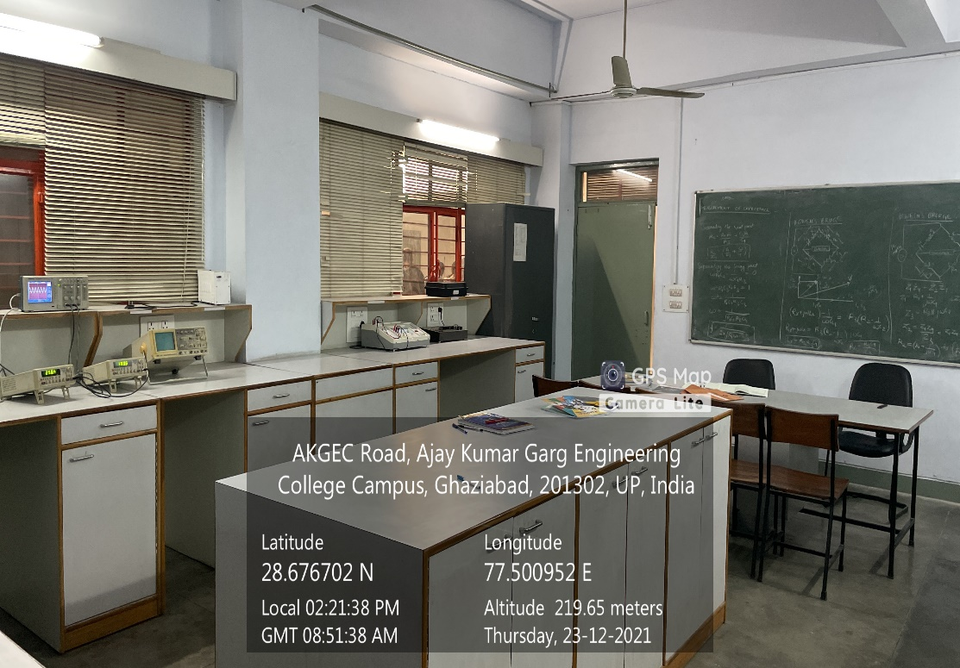

**ADMINISTRATIVE BLOCK SECOND FLOOR, ELECTRICAL INSTRUMENTATION LAB**

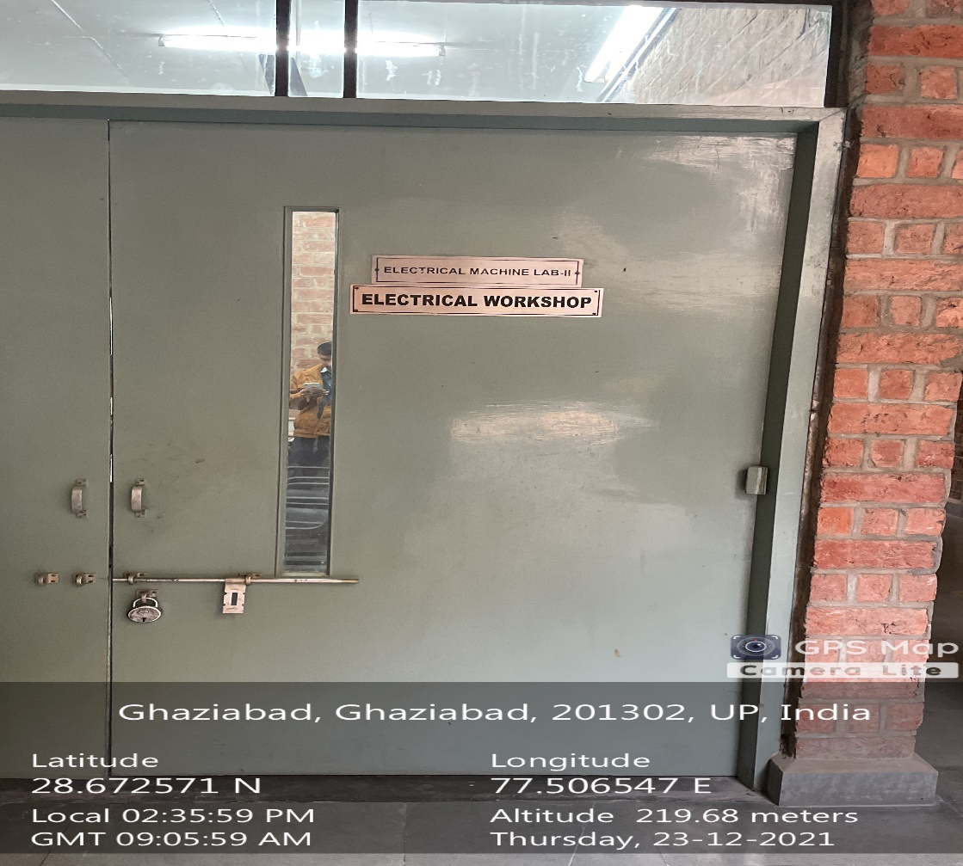

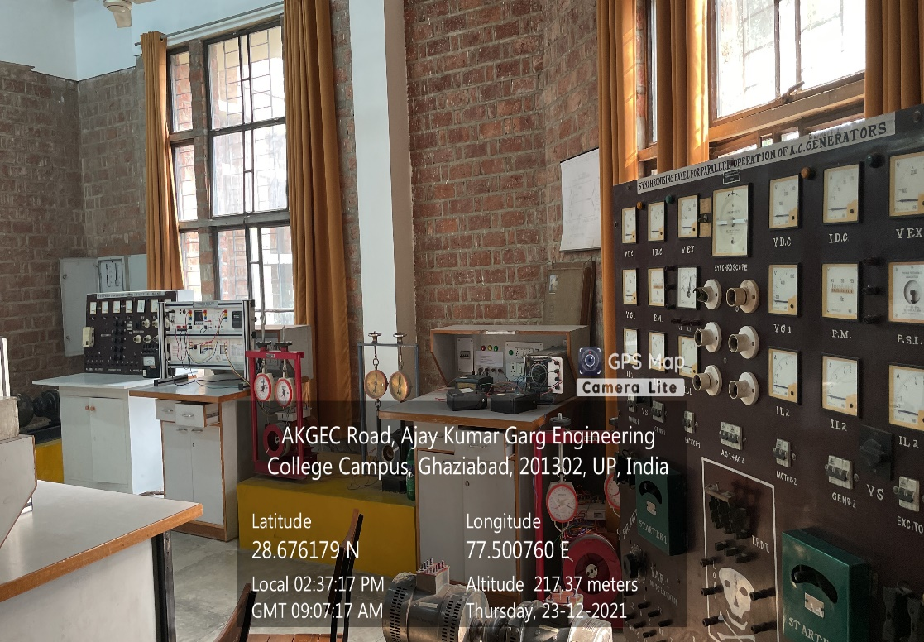

**ADMINISTRATIVE BLOCK GROUND FLOOR, ELECTRICAL WORKSHOP I**

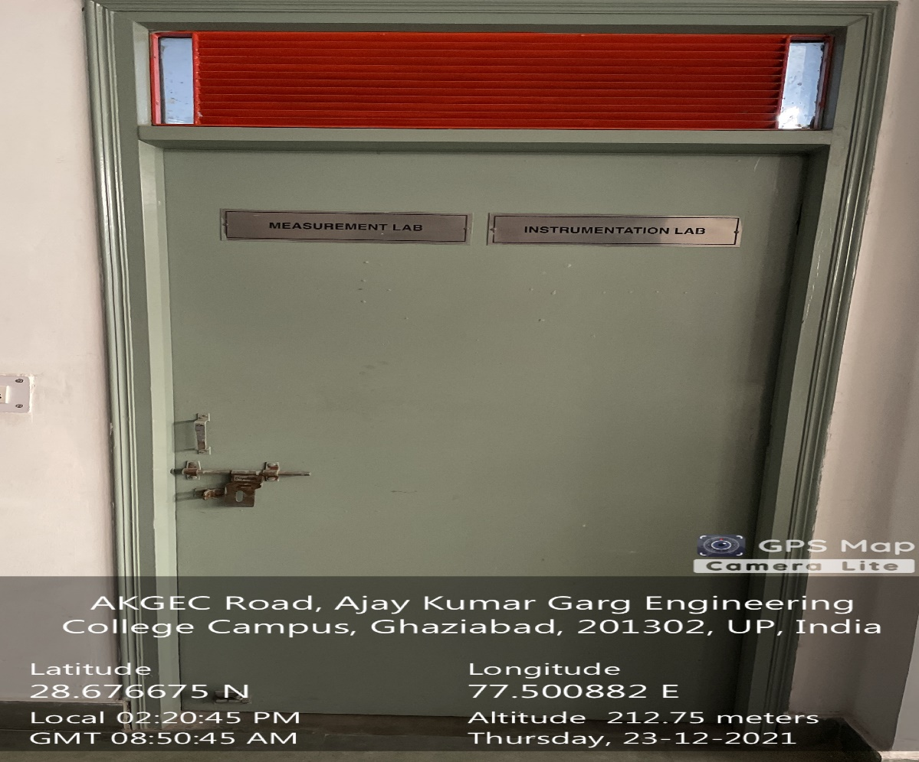

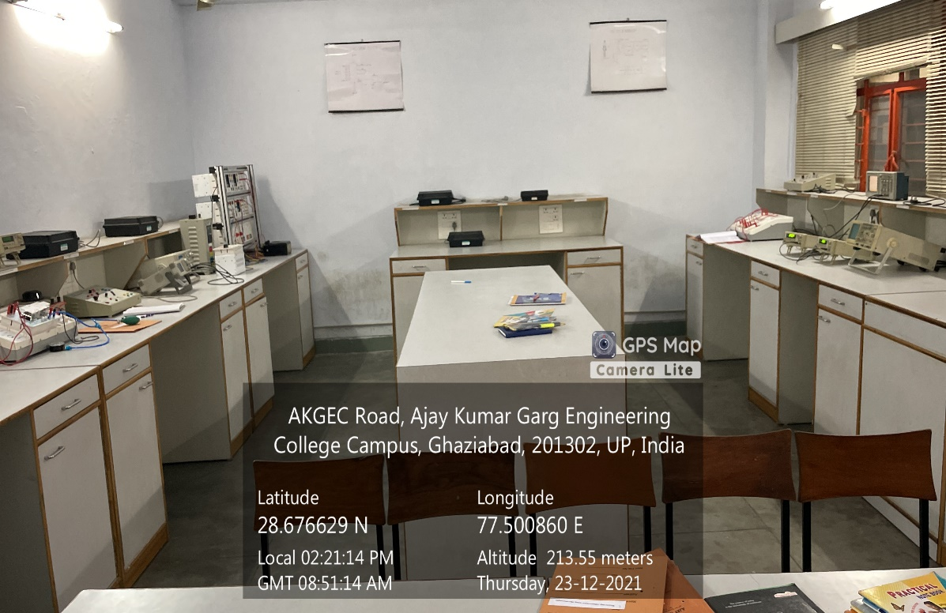

**ADMINISTRATIVE BLOCK SECOND FLOOR, EMMI LAB**

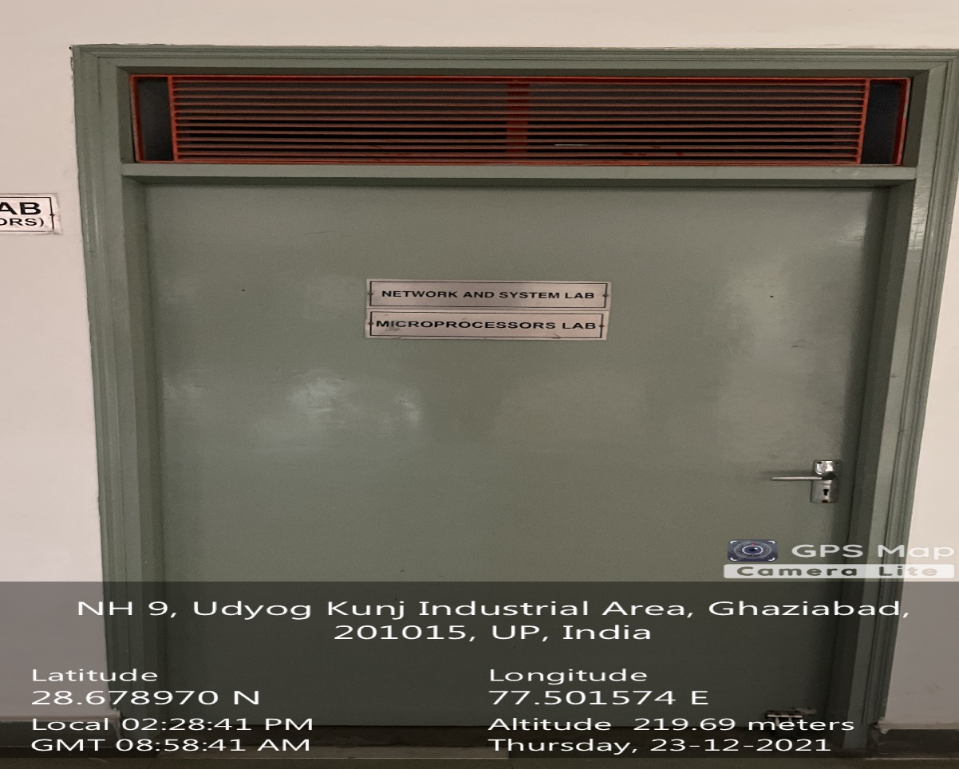

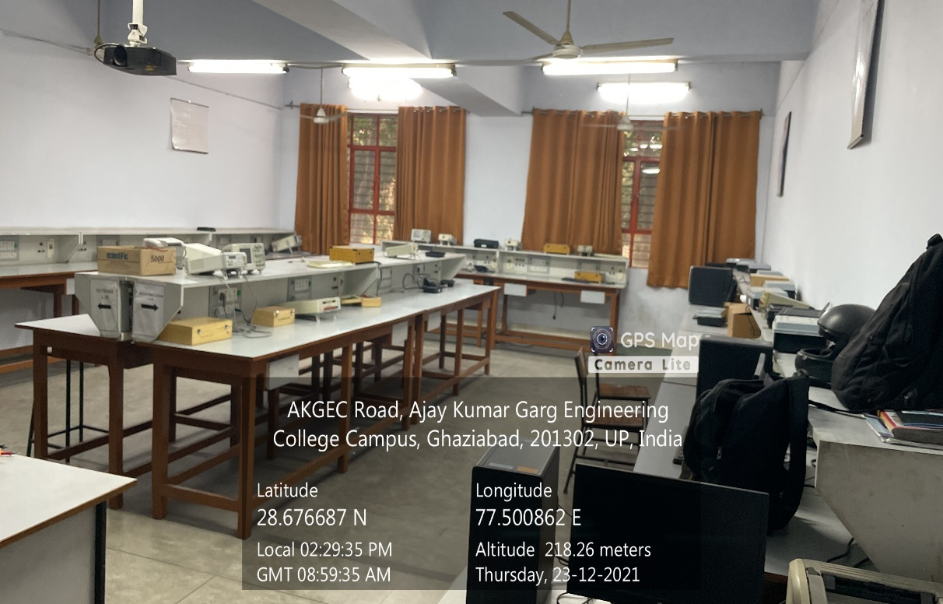

**ADMINISTRATIVE BLOCK GROUND FLOOR, MICROPROCESSOR LAB**

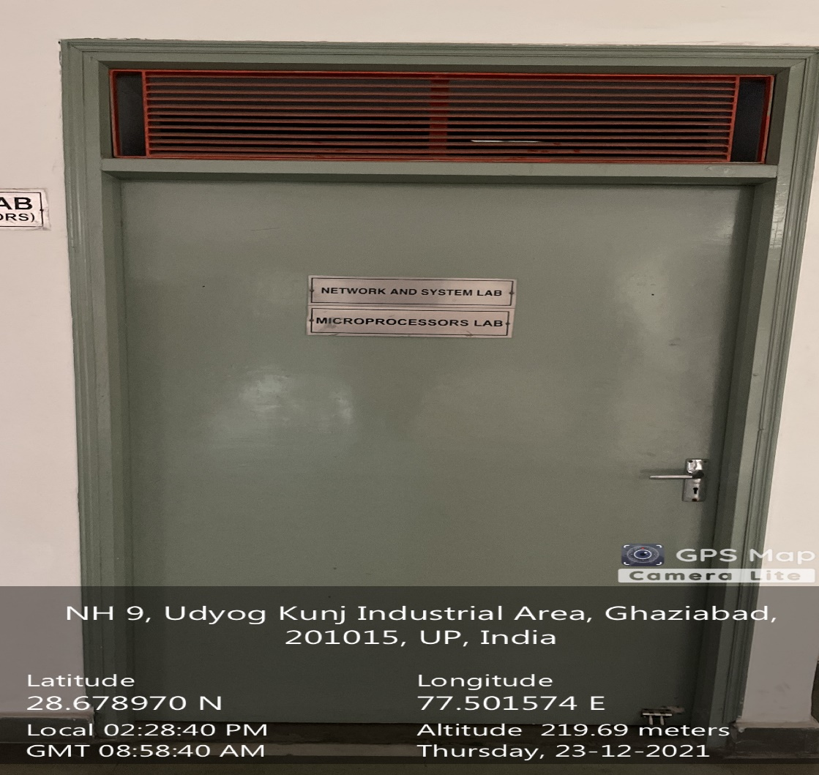

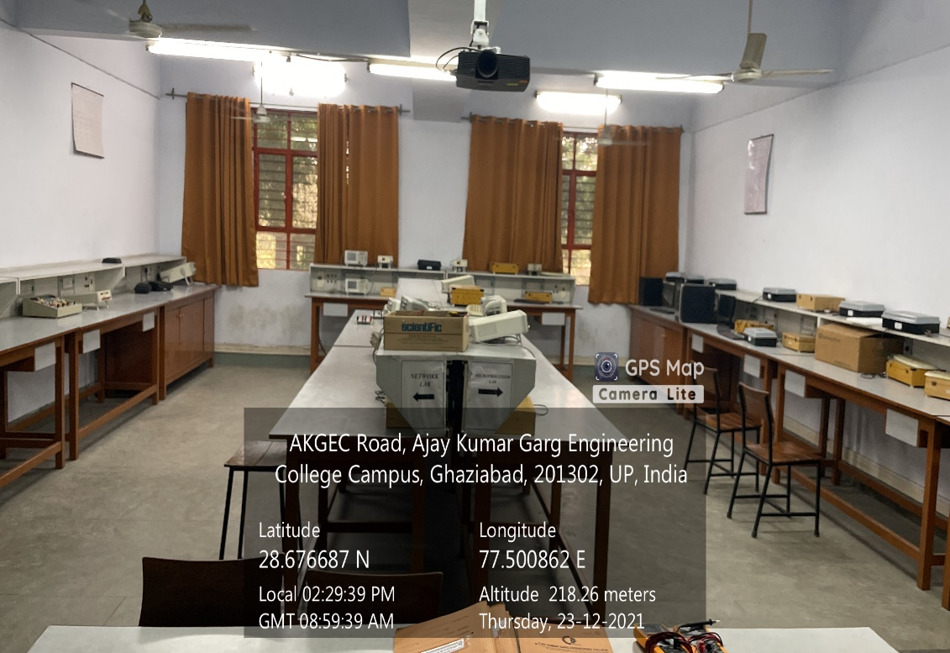

**ADMINISTRATIVE BLOCK GROUND FLOOR, NETWORK ANALYSIS & SYNTHESIS**

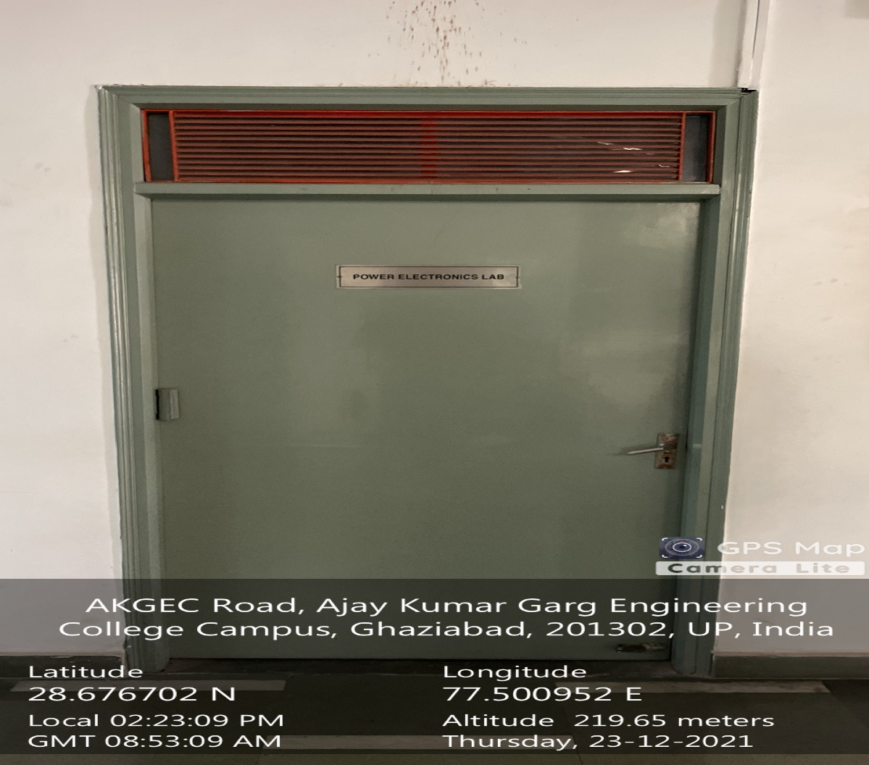

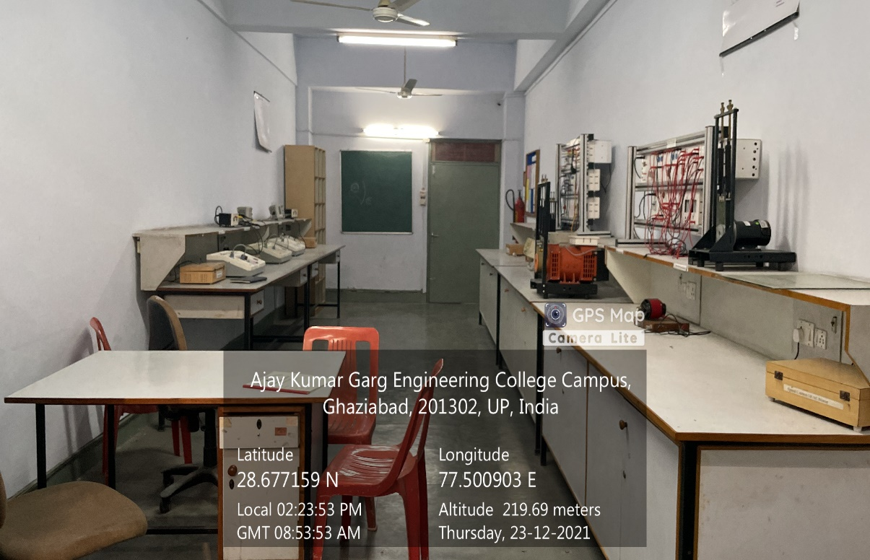

**ADMINISTRATIVE BLOCK GROUND FLOOR, POWER ELECTRONICS LAB**

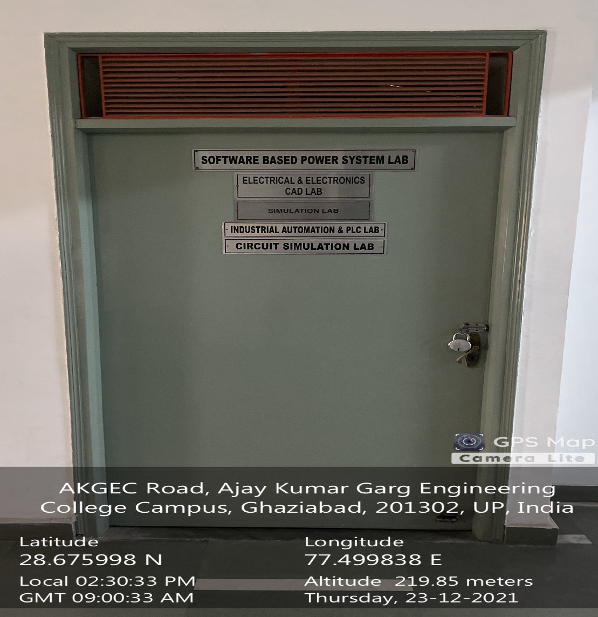

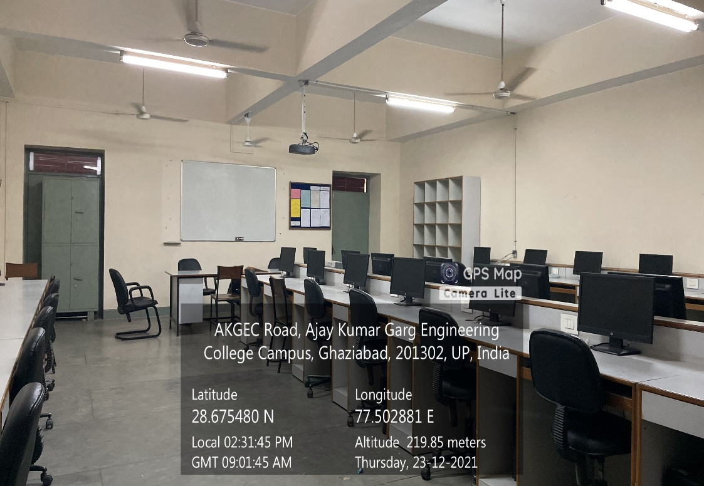

**ADMINISTRATIVE BLOCK GROUND FLOOR, SIMULATION LAB**